The columns have a lot of identifiers. And so designing the database calls for making different tables each representing a property…for example.

Addresses should be on a unique table, orders, ingredients etc

This strategy avoids redundancy and creates efficiency. The design practice is called **Data Normalization.**

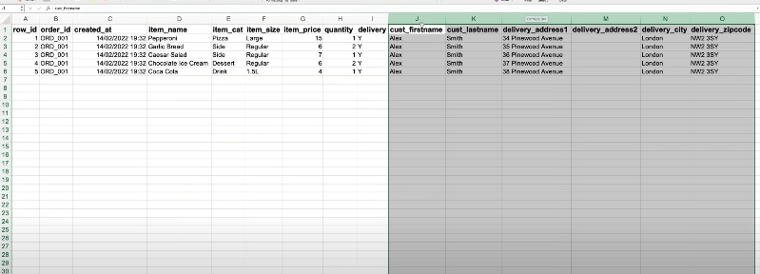

Quick DBD helps in this practice of designing models. The results look like this:

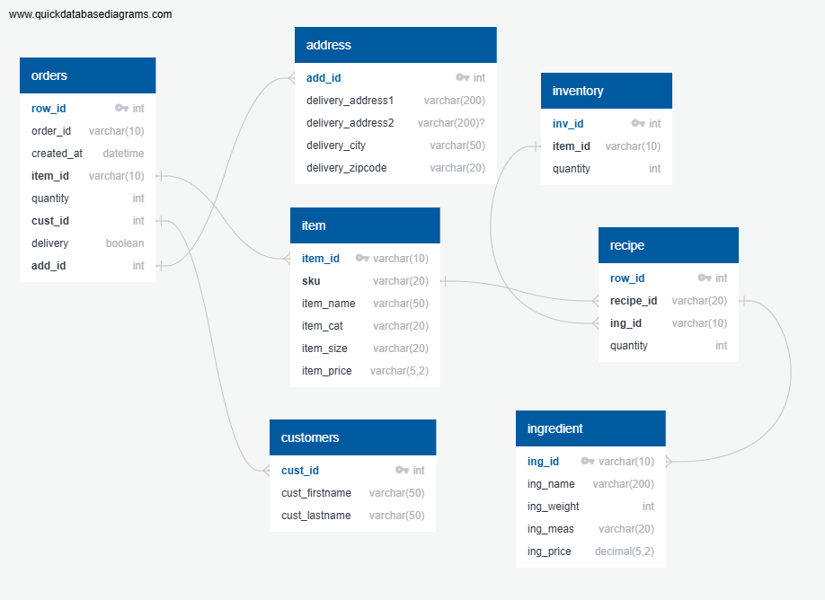

I can further export the design into SQL Management Studio, which help me create tables without executing queries. Later I will only import the CSVs containing the data for analysis.

